
Report Development -
Developer Information and Common mistakes and solutions
March 2006

Purpose and Audience

This document provides details of ediEnterprise’s developer information screen and report specification error reporting.

It should be read by anyone developing ediEnterprise reports.

Prerequisite reading and assumed knowledge

It’s assumed that the reader understands the basics of report development in ediEnterprise.
It’s recommended that the reader read the following before this document…

- ediEnterprise Report Development – Introduction
- ediEnterprise Report Development – Working with the database

Discovery

A comprehensive data dictionary doesn’t exist for ediEnterprise however the application itself provides tools that enable a developer to discover information about database fields.

A brief description of the application architecture is required to understand the discovery process.

From a developer’s point of view the application is broadly separated into a presentation layer, a business layer and a database layer.

The presentation layer is all of the forms and data entry or display controls that a user sees when using ediEnterprise.

The business layer is the part of the software that does all the work. It controls how data is entered, how it is displayed and how it is analysed.

From a report development perspective the database layer can be considered to be the database.

All controls in the presentation layer are associated with a field in the business layer. This association is called a binding and the controls are said to be bound.

A screen called the developer information screen allows users to investigate control binding.

The developer information screen can be accessed by clicking on any control and then hitting the Control, Shift and R keys simultaneously.

Figure 1 shows the results of doing this on the Organisation code text box on the Organisation form.

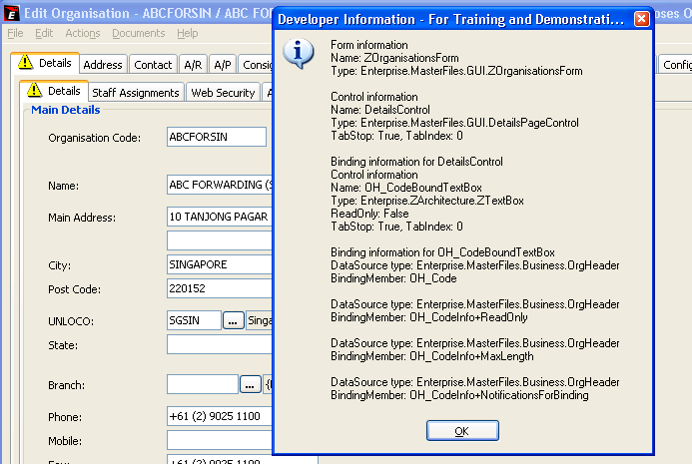
Figure 1

A lot of information is shown here but a report developer is usually looking for a database field so she would look for the characteristic format of a field i.e. the two letter code followed by an underscore and a name ( see working with the database for more details ). In this case the field is OH_Code.

As detailed ediEnterprise Report Development – Working with the Database, the OH_ tells the developer that they are dealing with an OrgHeader record and interrogating the database reveals that OrgHeader does indeed have an OH_Code field.

Types of Data Binding

Simple Persistent Fields

The above example is the simplest of a number of different data binding methods. Its an example of a simple persistent value. That is a value that is stored in the database without manipulating the user’s input.

Calculated Fields

The business layer is capable of performing complex transformations on the base data and often the presentation layer is not bound to a simple persistent field but is bound to a value that has been derived from several others.

For example, opening a consol, highlighting the Chargeable text box and accessing the developer information reveals that the control is bound to a field JK_TotalShipmentChargeable however interrogating the database reveals that the column does not exist on the JobConsol (JK) Table. The value is instead calculated in the business layer every time a consol is displayed. If a report developer needs information on how fields like this are calculated he will need to contact support.

Proxied Fields

Staying on the Consol form, accessing the developer information for Loading Port reveals that the control is bound to JK_JX_JA_RL_NKPortOfLoading. Again interrogating the database reveals that this field does not exist on the JobConsol table. However the field follows the same naming conventions as foreign keys within the database and so this name suggests that the field is derived from the relationship between JobConsol (JK), JobSailing (JX) and JobVoyOrigin(JA).

Interrogating the database for the field JA_RL_NKPortOfLoading on the JobVoyOrigin table reveals that it does exist. In these situations the value is said to have been proxied from the JobVoyOrigin to JobConsol.

Object Relationships

Values derived from the relationships between tables are not always proxied however. More often the relationships are represented by hierarchies. For example every JobShipment record has an associated JobDocsAndCartage record. For binding this relationship is accessed by traversing the hierarchy.

Accessing the developer information for the Pickup Frm text box on the Pickup tab of the Shipment form demonstrates such a traversal.

Here using the developer information it can be seen that the control is bound to DocsAndCartage+JP_EstimatedPickup. This notation tells the developer that the shipment’s DocsAndCartage relationship is being used and the field JP_EstimatedPickup on DocsAndCartage is what is being bound to.

In SQL this is equivalent to this…

SELECT
JP_EstimatedPickup
FROM
JobDocsAndCartage
INNER JOIN JobShipment ON JP_ParentID = JS_PK
WHERE
JS_UniqueConsignRef = Which ever shipment you want the estimated pickup for.

Trouble Shooting

The Document engine has been designed to help report developers determine when they’ve made a mistake and how to fix it.

To this end users are notified if a mistake in report specification has been made with the screen with an error screen as shown in figure 2.

As can be seen this screen isn’t very readable however copying the text to a file and opening it with an HTML reader or pressing Control, Alt and I simultaneously will make the message much more readable as show in Figures 3 and 4.
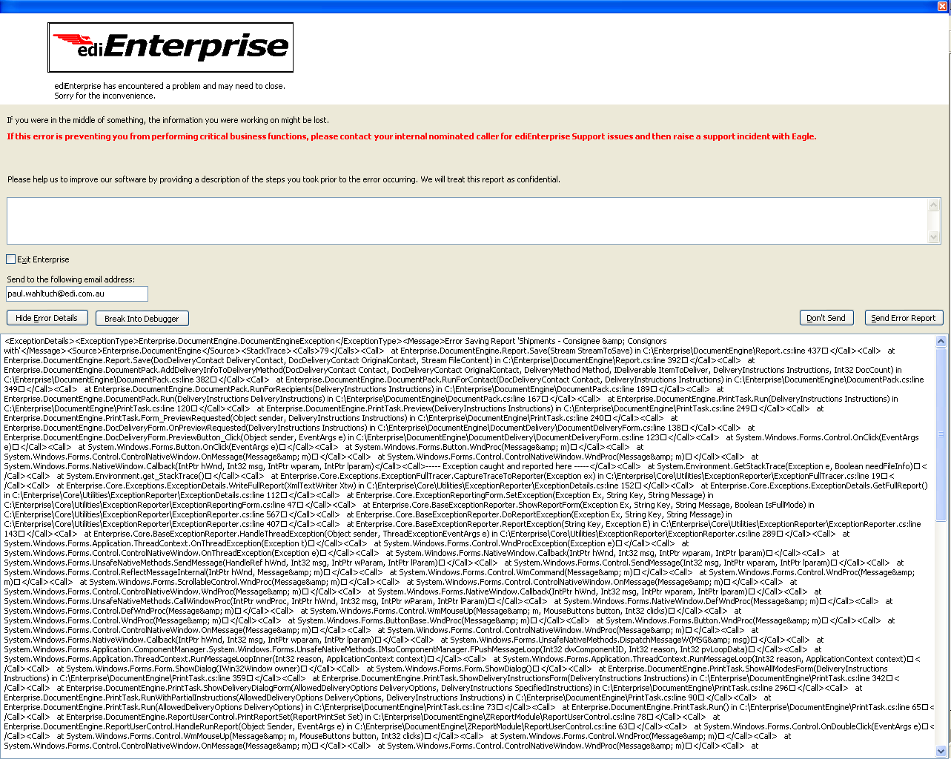
Figure 2
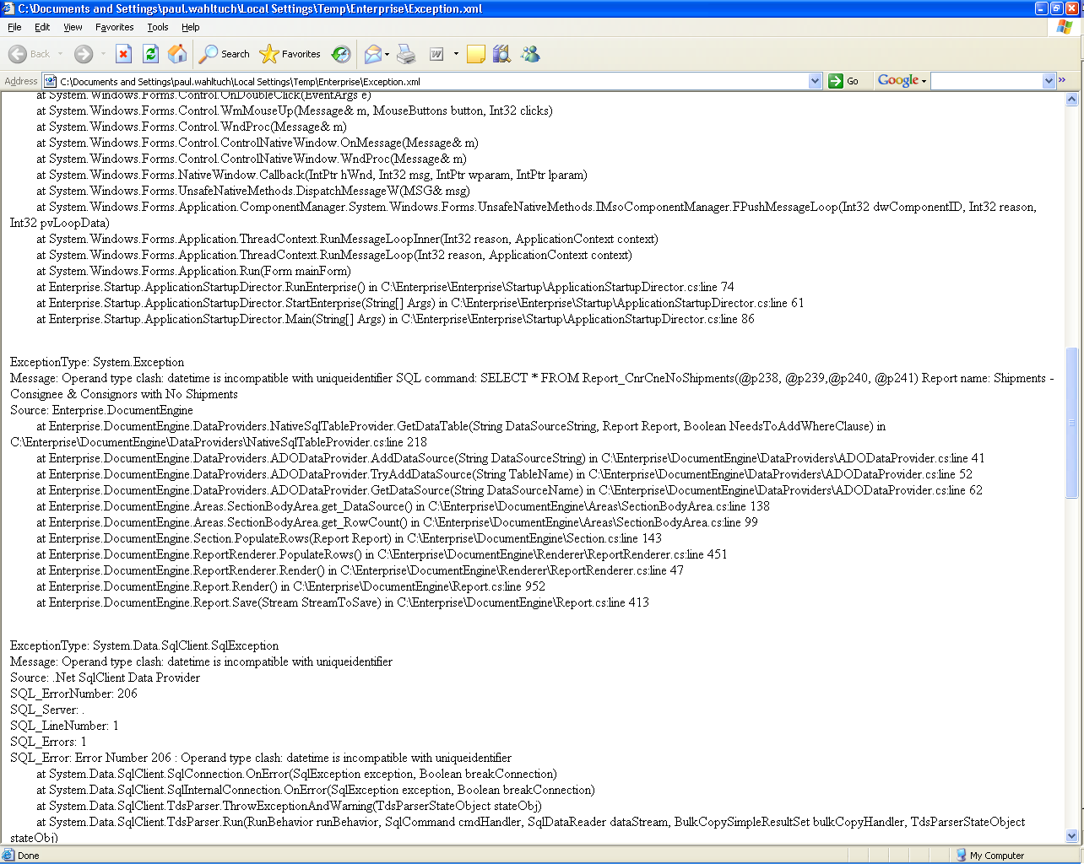
Figure 3

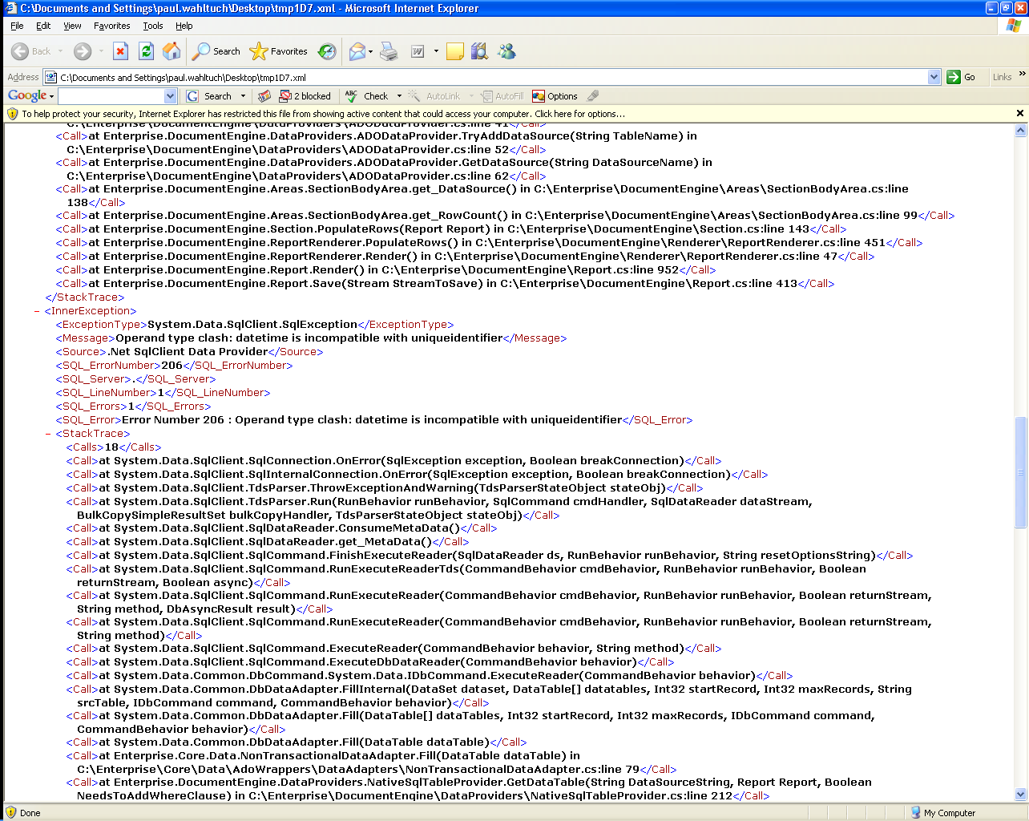
Figure 4

Due to the error handling process an error will return several layers of information. Look for the first example of an error type of system exception. This will usually be followed by a message describing the details of the error.

Report option errors are reported differently as shown in Figure 5.
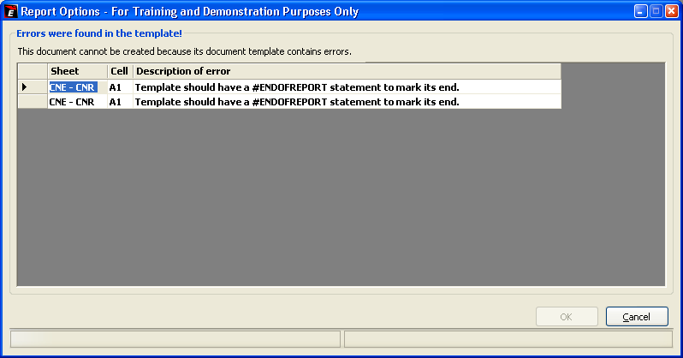
Figure 5
These errors are usually much more self explanatory so further explanation isn’t required.

Common Mistakes that cause Exception and their Solutions

Invalid Object name

ExceptionType: System.Exception
Message: Invalid object name 'Report_CnrCneNoShipments'. SQL command: SELECT * FROM Report_CnrCneNoShipments(@p28, @p29,@p30) Report name: Shipments - Consignee & Consignors with No Shipments

This error occurs when the report can’t find the table, view, function or stored procedure specified in the report’s data source.

In this example the function Report_CnrCneNoShipments cannot be found.

This is usually because a spelling mistake has been made specifying the data source or simply because the developer has not yet compiled the object.

Procedure or function X has too many/Not enough arguments

ExceptionType: System.Exception
Message: Procedure or function Report_CnrCneNoShipments has too many arguments specified. SQL command: SELECT * FROM Report_CnrCneNoShipments(@p45, @p46,@p47,@p48,@p49,@p50,@p51) Report name: Shipments - Consignee & Consignors with No Shipments

This is pretty self explanatory.

Operand type clash: type A is incompatible with type B

ExceptionType: System.Exception
Message: Operand type clash: datetime is incompatible with uniqueidentifier SQL command: SELECT * FROM Report_CnrCneNoShipments(@p238, @p239,@p240, @p241) Report name: Shipments - Consignee & Consignors with No Shipments

This often related to 6.2. It occurs when the data type of the value being passed into a parameter cannot be converted to the actual type of the parameter.

The most frequent cause of this is that parameters have been specified in the wrong order.

The next most frequent cause is the way the developer has used ediEnterprise report filters. Lookup type filters by default return a SQL UniqueIdentifier ( GUID ) but CodeLookup filters return a text code. It’s common to mix these up and pass in one on place of the other. Most Lookup type filters implement a .Code modifier that will be useful if a parameter is expecting a code.

No provider is responsible for replacing macro X

ExceptionType: Enterprise.DocumentEngine.DocumentEngineException
Message: Error: no provider is responsible for replacing macro "Transaction Debtor" in report/document "Shipments - Consignee & Consignors with".

This error occurs when a macro has been used in the template that doesn’t exist.

The most common cause of this is a difference between the spelling of a filter on the filter sheet and the spelling of it’s use in the template.

Another common cause is when a developer copies an existing template, removes unwanted filters form the filter sheet but forgets to remove references to those filters form the template.

Common Mistakes that do not cause Exceptions

There are a few errors that will not cause exceptions but that should be looked for by report developers.

Default Macro Values that should not be used for display puposes

It is common practice to include a Chosen Filters line in a report to show the report user what filter choices they have made.

It’s a common mistake to rely on the default return value of the filter for display puposes. As mentioned above many filters return a GUID by default which is meaningless to a user. Using the .Code qualifier on a marco will usually return something more meaningful to a user.

Column X cannot be found in Data Source Y

When using data sources it is common to incorrectly specify the name of a column in that data source.

This will not cause an exception, instead the column will contain the message Column X cannot be founding data source Y.

Developers need to pay special attention for this as it’s easy to miss.

